**PROJECT REPORT ON SMART BAGGAGE TRACKER**

**Title:-**

RFID based luggage tracker

**Background and research:-**

**a) Present method of tackling the problem:-**

The most popular methods are long-range tracking solutions like LugLock and Trakdot, and new luggage with built-in sensors. Trakdot, a $49 gadget uses cellular technology to keep tabs. In order to use Trakdot's mobile app, you need cellular service or access to Wi-Fi. It also needs batteries which supply power to the system.

The next evolutionary step in tracking technology is luggage with the systems already built in. The bags, called "smart" luggage, use a variety of technologies, including global positioning (GPS) and Bluetooth, to round up lost bags.

The biggest names in smart luggage are Bluesmart and Raden. Bluesmart's One carry-on, for example, uses integrated GPS technology to follow your valuables, with no monthly service fee. Raden's A22 Carry ($295) uses Bluetooth technology to track your bag in an airport. Both have their own apps that can find and even weigh your luggage.

Existing solutions also include baggage tracking with the help of barcodes.

**b) Limitations of present solutions:-**

Although solutions like Trakdot do indeed last long enough for an entire lengthy trip with full service on a single charge, it does require two AA batteries. This inherently increases the total cost of ownership, especially if the person travel often and purchase durable batteries. Apart from this it won’t be able to track luggage if it does not have access to cellular network or WiFi.

**c) Alternate approaches:-**

Currently, the majority of airlines use simple barcodes for baggage handling. Barcodes are cheap, simple to use and a trusted technology. However, they also have distinct disadvantages. Not only do they require line-of-sight reading, often with a handheld scanner, but also where tested alongside RFID, barcode technologies provide read rates as low as 60 - 70%, while RFID read rates can be as high as 97 - 99.9%. Furthermore, when airports have adopted RFID over barcode systems, their weekly equipment maintenance requirements have typically dropped to just once a year.

Airports and airlines do not need to choose between RFID or barcode for baggage identification and tracking. More and more solutions utilizing both technologies are being introduced to the market. These hybrid solutions make airports capable of handling both barcode and RFID-tagged baggage. It is most likely that both technologies will be present, and by adapting hybrid solutions, airports can gain the benefits from both. A hybrid solution would typically have a higher read rate than by using the technologies separately. Partial implementation of RFID with hybrid solutions can be a first step towards a full implementation of RFID.

**d) Proposed solution:**

Baggage handling involves numerous steps from when a passenger checks in his or her bag, to when they retrieve it at the final destination. These include:

* Receive the bag from the passenger
* Move the bag through security
* Store the bag until the flight is ready for loading
* Sort the bag so it can be loaded onto the correct flight
* Load the bag onto the correct flight
* Deload the bag from flight and repeat the process of storing, sorting and loading if there is any connecting flight.

With so many different stages in the baggage handling process, it is no surprise that things can and do go wrong. Various technologies can be deployed to address the tracking challenge, but we believe RFID has the most all round effectiveness as well as unique capabilities that support process improvement by enabling far greater visibility into baggage handling operations than ever before.

RFID tag readers will be placed at various places such as at security check in, where bags are loaded at the plane, where bags are deloaded from plane, when they are placed on the conveyer belt etc. When the bag crosses each of these stages a corresponding message will be sent to the respective passenger as well as airport staff about the status of bag. Also when the baggage taps on first card reader, entire information of that passenger will be stored in the database created for the airline which will further help the airline to provide better services and will reduce paper work and make entire system digital. If a baggage gets misplaced in the process, it becomes much easier to relocate it as we know exactly the stage at which it had got misplaced.

**e) Novelty of approach:-**

Barcode scanner requires line-of-sight reading, often with a handheld scanner. When tested alongside RFID, barcode technologies provide read rates as low as 60 - 70%, while RFID read rates can be as high as 97 - 99.9%. Furthermore, when airports have adopted RFID over barcode systems, their weekly equipment maintenance requirements have typically dropped to just once a year. RFID tags do not require any power supply and hence there is no cost of ownership for the customer as compare to GPS based trackers wherein durable cells needs to be replaced frequently. Hence RFID based smart tracking system is economical and easy to implement.

**Problems it solves and its beneficiaries:-**

According to the annual report of airline information technology company [SITA](http://www.sita.aero/) on airline baggage handling, 6 bags per 1,000 passengers were mishandled last year. That's down 12.5 percent year over year. About 26 billion bags get misplaced each year. This number is huge and this problem cost large amount of money to airlines. Hence we proposed a solution which is very much economical, easy to implement and will have a tremendous impact on entire turnout of airline.

Advantages of using RFID based tracking system are as follows:-

1. Allows passengers to track baggage in real-time and creates passenger loyalty
2. Lower the number of delayed and lost baggage, which have a potential saving of at least $100 per bag.
3. Decrease need for manual processing, which helps you free up staff for other value adding tasks
4. Full compliance of IATA 753 done in the most cost-effective way
5. Shorter loading/off loading time with automatic on and off-load scannings, which results in a reduction of ground time and a higher average miles pr. seat.
6. Better read rates on transfer bags, which increases capacity and enables growth without new infrastructure investments.
7. Not requiring line-of-sight reading unlike barcodes
8. Read points are relatively low cost
9. Can be read from a distance
10. RFID tag does not tear apart from handling
11. Can read multiple tags simultaneously, unlike barcodes
12. Can read bag tags more accurately and efficiently compared to barcodes
13. Readers are easy and cost-effective to deploy

**Plan (with timeline) and current status:-**

**Technical details:-**

**a) Technical aspect of proposed solution**

**Hardware required:-**

Real time baggage tracker

Arduino uno

LCD

EM 18 (RFID reader)

GSM module

SIM card

Connecting Wires

Smart baggage

Arduino

Motor driver

Servo motors

Bluetooth module (HC05)

Push button

Buzzer

Ultrasonic sensor (HCS04)

**Connections for smart luggage tracker:-**

The module radiates 125KHz through its coils and when a 125KHz passive RFID tag is brought into this field it will get energized from this field. These passive RFID tags mostly consist of CMOS IC EM4102 which can get enough power for its working from the field generated by the reader. By changing the modulation current through the coils, tag will send back the information contained in the factory programmed memory array.

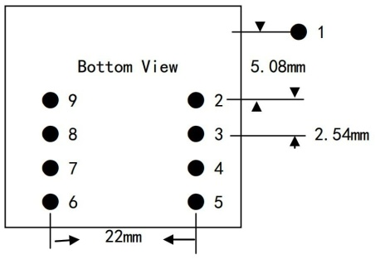

RFID reader module bottom view

|  |  |  |
| --- | --- | --- |
| Pin No. | Name | Function |
| 1 | VCC | 5V |
| 2 | GND | Ground |
| 3 | BEEP | BEEP and LED |
| 4 | ANT | No Use |
| 5 | ANT | No Use |
| 6 | SEL | HIGH selects RS232, LOW selects WEIGAND |
| 7 | TX | UART TX, When RS232 is Selected |
| 8 | D1 | WIEGAND Data 1 |
| 9 | D0 | WIEGAND Data 0 |

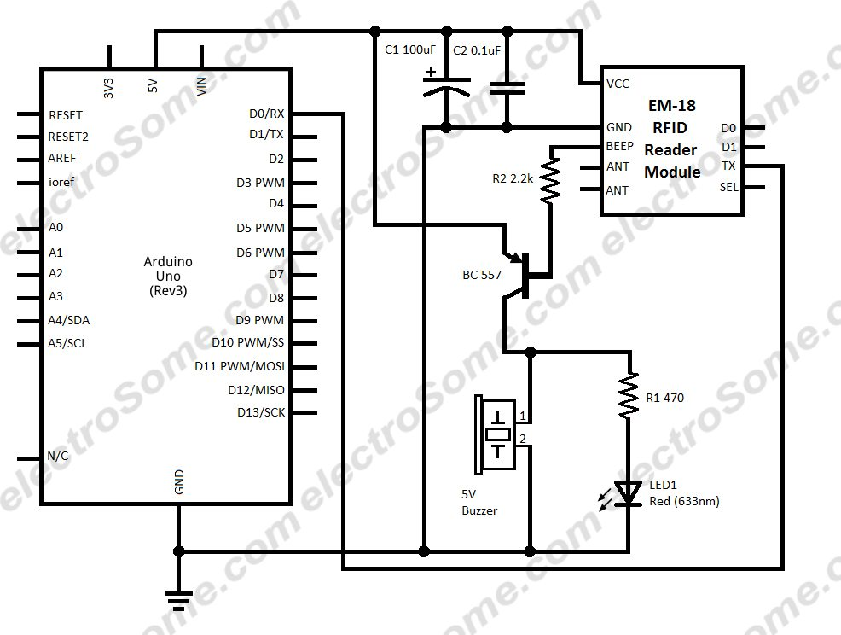 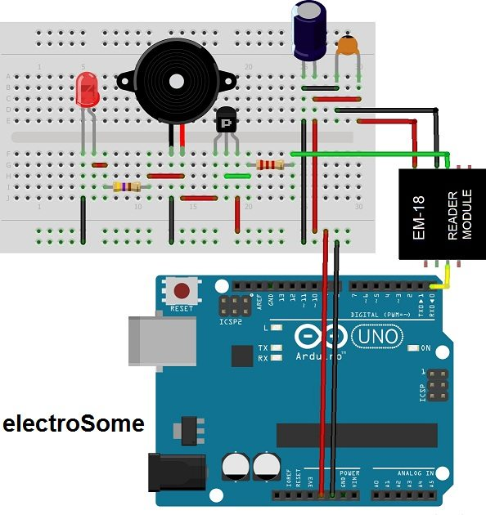

Circuit diagram and breadboard wiring

**Interfacing GSM with arduino**

1. Insert the SIM card to module and lock it.

2. Connect the adapter to module and turn it ON!

3. Now wait for some time (say 1 minute) and see the blinking rate of ‘status LED’ (GSM module will take some time to establish connection with mobile network)

4. Once the connection is established successfully, the status LED will blink continuously every three seconds.

5. Make connections:- We are supposed to use serial pins of Arduino (Rx and Tx). Connect the Tx pin of GSM module to Rx pin of Arduino and Rx pin of GSM module to Tx pin of Arduino. Now connect the ground pin of arduino to ground pin of GSM module

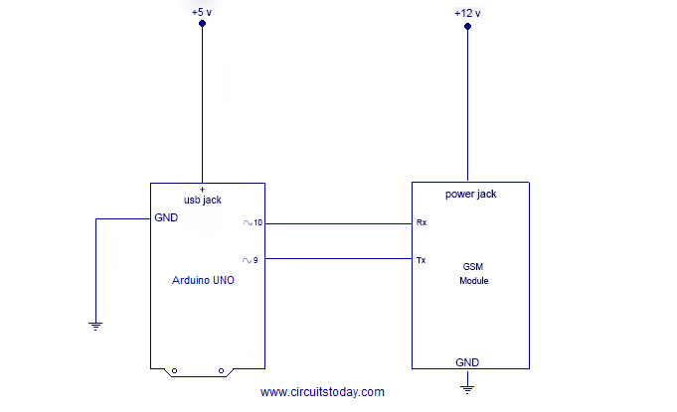

Circuit diagram

**Interfacing LCD with arduino**

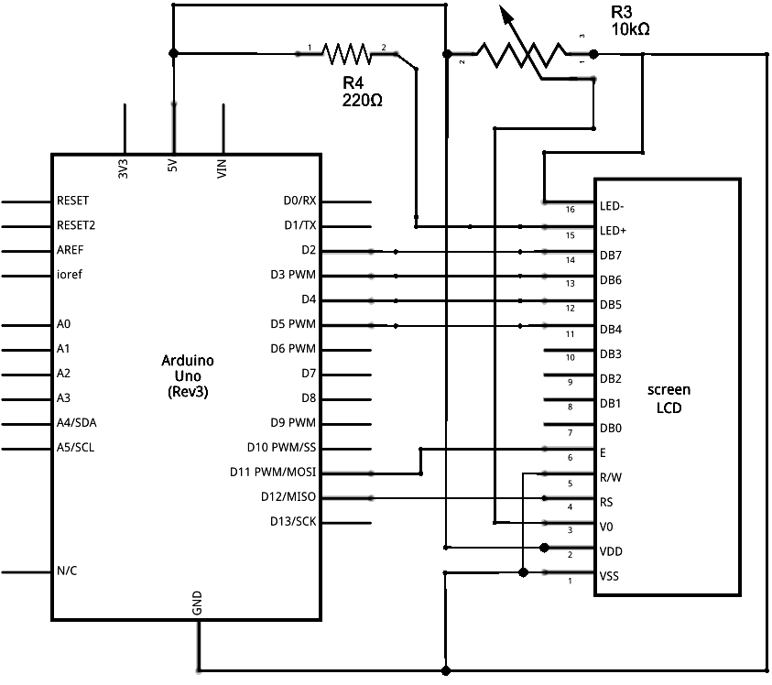

Circuit diagram

Pin 1 to GND  
Pin 2 to 5V  
Pin 3 to wiper  
Pin 4 to Arduino pin 13  
Pin 5 to GND  
Pin 6 to Arduino pin 12  
Pin 11 to Arduino pin 11   
Pin 12 to pin 10  
Pin 13 to pin 9  
Pin 14 to pin 8

Pin 15 to one side of resistor and other side of resistor is connected to GND

Pin 16 to GND

**Smart baggage:-**

**Interfacing L239D motor driver with arduino**

The L293D is a 16-pin Motor Driver IC which can control a set of two DC motors simultaneously in any direction. The L293D is designed to provide bidirectional drive currents of up to 600 mA (per channel) at voltages from 4.5 V to 36 V (at pin 8!). Connections can be easily done using the following circuit.

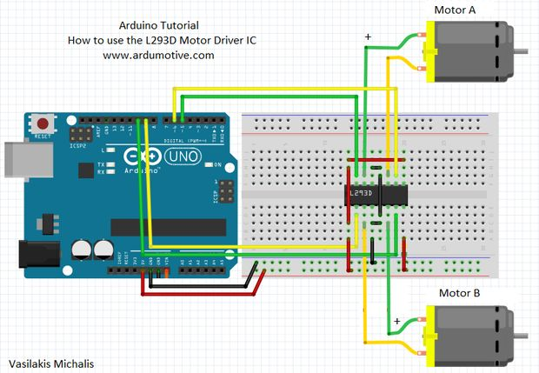 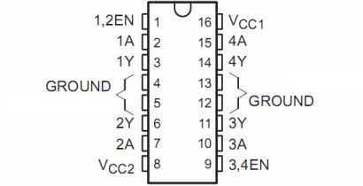

**Interfacing HC05 (Bluetooth module) with arduino**

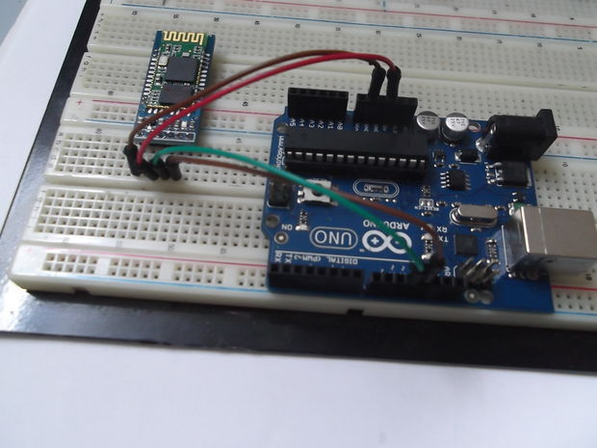

Tx pin of Bluetooth to rx pin of arduino

Rx pin of Bluetooth to tx pin of arduino

Gnd of bluetooth to Gnd of arduino

Vcc to +5v of arduino

**Interfacing with ultrasonic sensor:-**

The HC-SR04 is an ultrasonic ranging module. This economical sensor provides 2cm to 400cm of non-contact measurement functionality with a ranging accuracy that can reach up to 3mm. Each HC-SR04 module includes an ultrasonic transmitter, a receiver and a control circuit.

There are four Pinson the HC-SR04. They are :

* Vcc (5V supply)
* Gnd (Ground)
* Trig (Trigger)
* Echo (Receive)

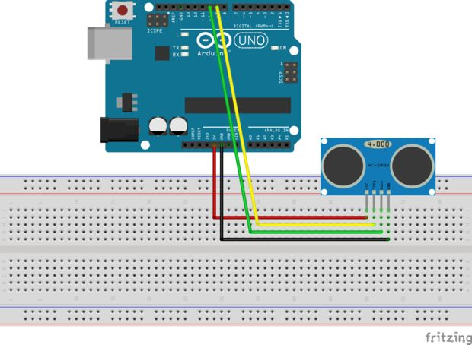

b) Detailed technical specifications and Pictorial representations (block diagrams/ flow chart)

Real time baggage tracker:-

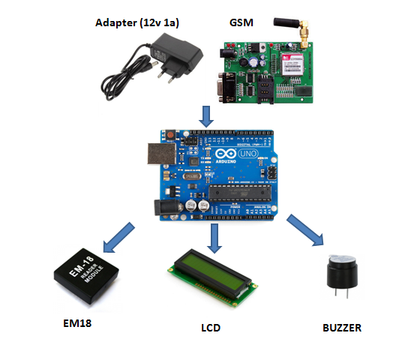

Smart luggage:-

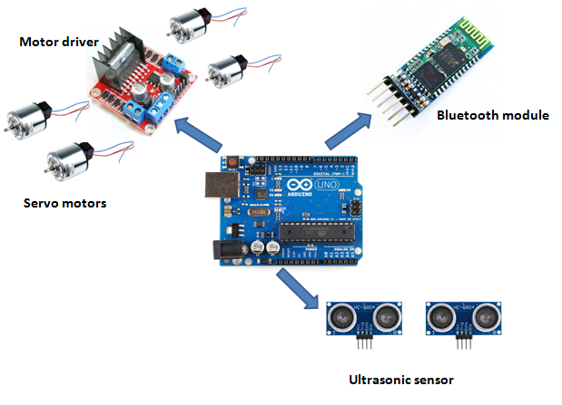

**c) Description of the flow of operations demonstrating key features and functionality.**

Real time baggage tracker:-

RFID cards consist of a (12 digit) unique ID as well as small amount of memory that can be easily accessed. In order to differentiate between flights, we will write into the card a unique id for a particular Flight and a unique Id for the customer.

When the baggage is received from the customer and sent to the security, rfid card attached to baggage will be tapped on the device for the first time and message will be sent through GSM module to customer as well as airline staff that it has crossed the security. Customer’s personal details will be recorded in a database which is created for the airline. Similarly corresponding message will be sent to customer about the status of baggage for further stages like loading, sorting, deloading etc. If luggage is sent on wrong flight, immediately it will get flashed on the LCD attached with hand held baggage tracker and buzzer will beep for 3 seconds. In response to this alert, staff will immediately take it off and will transfer it to correct flight. Hence, baggage tracking becomes much more easier and economical.

Smart Baggage:

It is controlled by smartphone using bluetooth module. First we need to connect HC05 module attached on baggage with our phone’s bluetooth. Then we can easily control it by the application. In order to move forward, backward, right or left we need to press F, B, R and L respectively. Ultrasonic sensor is used to detect the distance of an obstacle and buzzer will beep for 5 seconds if obstacle is within the range of 10 cm. Buzzer will beep for 2 seconds if obstacle is within the range of 30 cm and will not beep otherwise. Motor driver is used to control servo motors which are attaches to wheels of the baggage.